 



Database Programming with SQL

* 1. : Oracle Nonequijoins and Outer Joins Practice Activities

# Objectives

* + - Construct and execute a SELECT statement to access data from more than one table using a nonequijoin
    - Create and execute a SELECT statement to access data from more than one table using an Oracle outer join

# Try It / Solve It

1. Create a join based on the cost of the event between the DJs on Demand tables D_EVENTS and D_PACKAGES. Show the name of the event and the code for each event.

SELECT d_events.name, d_packages.code

FROM d_events, d_packages

WHERE(d_events.cost BETWEEN d_packages.low_range AND d_packages.high_range);

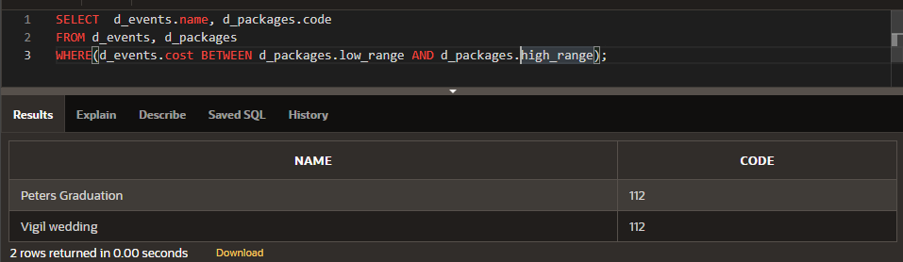

1. Using the Oracle database, create a query that returns the employee last name, salary, and job- grade level based on the salary. Select the salary between the lowest and highest salaries.

**SELECT employees.last_name, employees.salary, job_grades.grade_level**

**FROM employees,job_grades**

**WHERE employees.salary BETWEEN job_grades.lowest_sal AND job_grades.highest_sal;**

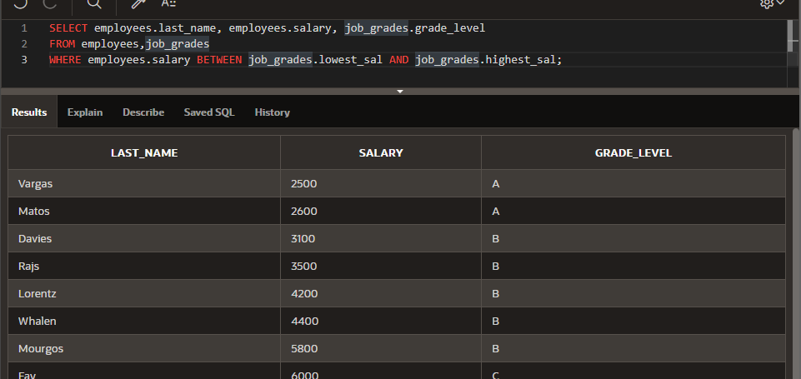

1. What condition requires the creation of a nonequijoin?

**Если нет точного совпадения между двумя столбцами, но есть определенная связь**

1. Rewrite the following nonequijoin statement using the logical condition operators (AND, OR, NOT): WHERE a.ranking BETWEEN g.lowest_rank AND g.highest_rank

**WHERE  a.ranking >= g.lowest_rank AND a.ranking <= g. highest_rank**

1. How do you know when to use a table alias and when not to use a table alias?

Использование псевдонимов сокращает запись и упрощает чтение, также оно помогает различать столбцы с одинаковыми именами, чтобы не писать полные пути, Псевдонимы используются везде, если созданы.

1. What kind of join would you use if you wanted to find data between a range of numbers?

Non equijoin. – неэквивалентное соединение

1. You need to produce a report for Global Fast Foods showing customers and orders. A customer must be included on the report even if the customer has had no orders.

**SELECT f_customers.first_name ||' '|| f_customers.last_name "Customer Name", f_orders.order_number, f_orders.order_total, f_orders.order_date**

**FROM f_customers, f_orders**

**WHERE  f_customers.id = f_orders.cust_id(+);**

+ это эквивалент LEFT OUTER JOIN

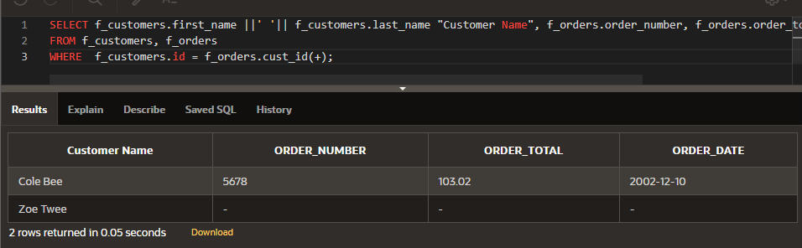

1. Create a query of the Oracle database that shows employee last names, department IDs, and department names. Include all employees even if they are not assigned to a department.

**SELECT employees.last_name, employees.department_id, departments.department_name**

**FROM employees, departments**

**WHERE employees.department_id = departments.department_id(+);**

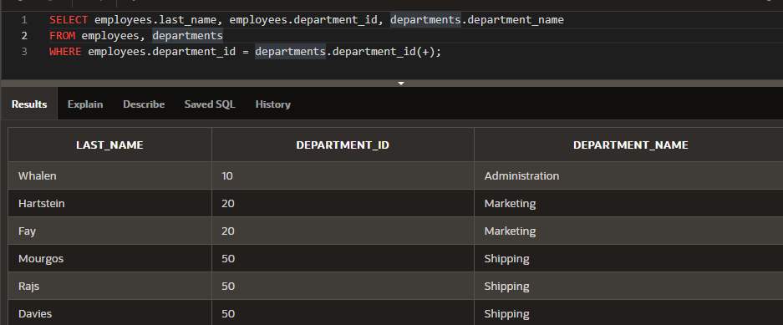

1. Modify the query in problem 8 to return all the department IDs even if no employees are assigned to them.

**SELECT employees.last_name, employees.department_id, departments.department_name**

**FROM employees, departments**

**WHERE employees.department_id(+) = departments.department_id;**

+ здесь это как RIGHT OUTER JOIN

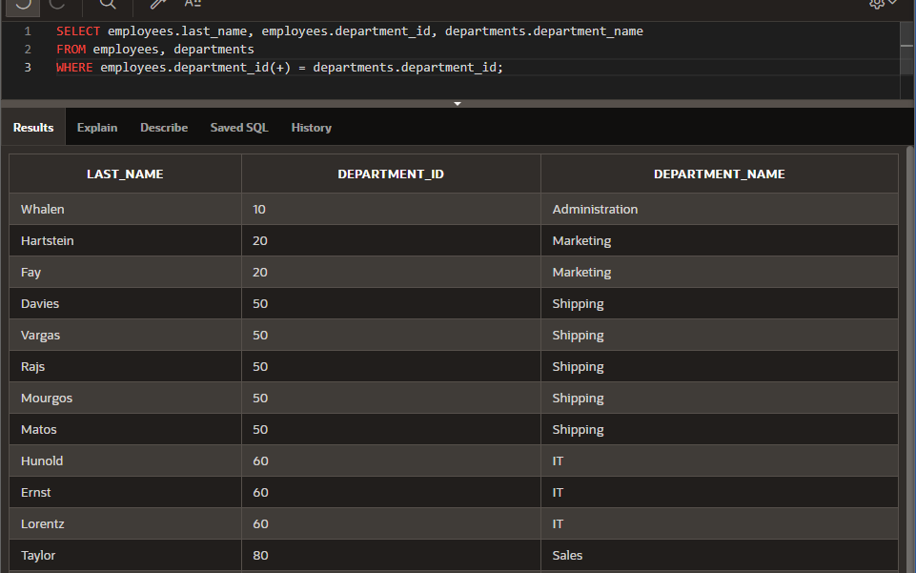

1. There are one or more errors in each of the following statements. Describe the errors and correct them.
   1. WHERE e.department_id(+) = d.department_id (+);

**WHERE e.department_id  = d.department_id (+);**

**WHERE e.department_id(+) = d.department_id;**

Нет эквивалента в + для FULL OUTER JOIN поэтому либо RIGHT либо LEFT

* 1. SELECT e.employee_id, e. last_name, d. location_id

FROM employees e, departments d

WHERE e.department_id = d.department_id(+);

1. Create a query that will show all CD titles and song IDs in the DJs on Demand database even if there is no CD number in the track-listings table.

**SELECT d_cds.title , d_track_listings.song_id**

**FROM  d_cds, d_track_listings**

**WHERE d_cds.cd_number = d_track_listings.cd_number(+) ;**

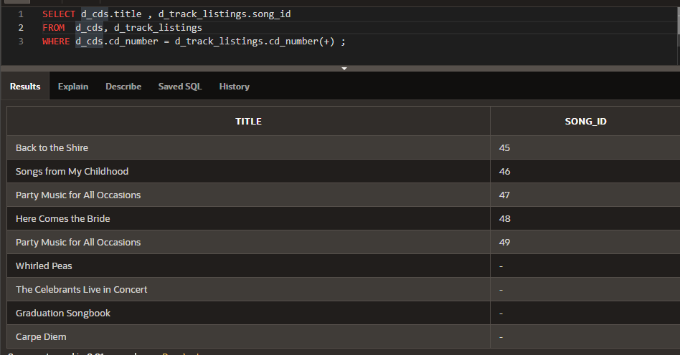

1. How many times has someone asked you: “What do you want to be when you grow up?” For most of us, the first thing that comes to mind is something like business manager, engineer, teacher, game designer, doctor, scientist, computer programmer, or accountant -- all pretty much traditional career choices. Have you ever thought about working in an odd job or nontraditional career? There are people who are professional shoppers for busy executives, directors of zoos, recipe designers, insecticide chemists, golf-course designers, and turf managers. Picture yourself in a dream job or nontraditional career doing something that you think would be interesting, life fulfilling, and profitable.

Use Internet resources to explore your idea. Write a brief description of the job to share with the class.

Copyright © 2020, Oracle and/or its affiliates. All rights reserved. Oracle and Java are registered trademarks of Oracle and/or its affiliates. Other names may be trademarks of their respective owners.